**Semester End Practical Exam!!**

**Name:** Dhavalkumar Vijaykumar Patel

**Class:** M.Sc. Cyber Security Sem-3

**Enrollment Number:** 032200300002034

**Subject:** Social Network Analysis (CTMSCS SIII L5 EL1)

**Date:** 09 January 2024

**Task – 1**

1. Where was the photo taken?

Download the image

Use image reverse look up to find the photo

You will find the similar image and place information

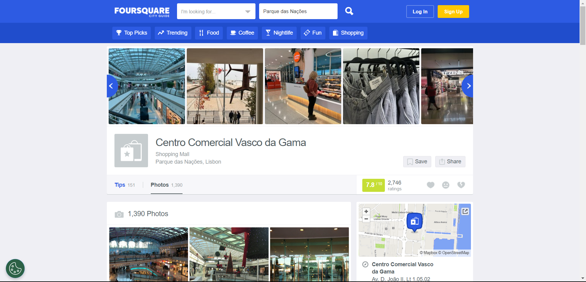

The photo taken at : Centro Commercial Vasco da gama

Search the Map to find the co-ordinates

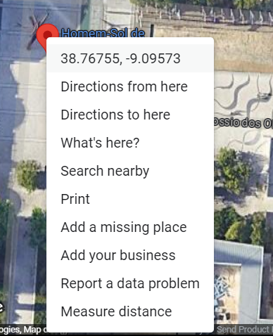

Coordinates: 38.76755986286469, -9.09570186082792

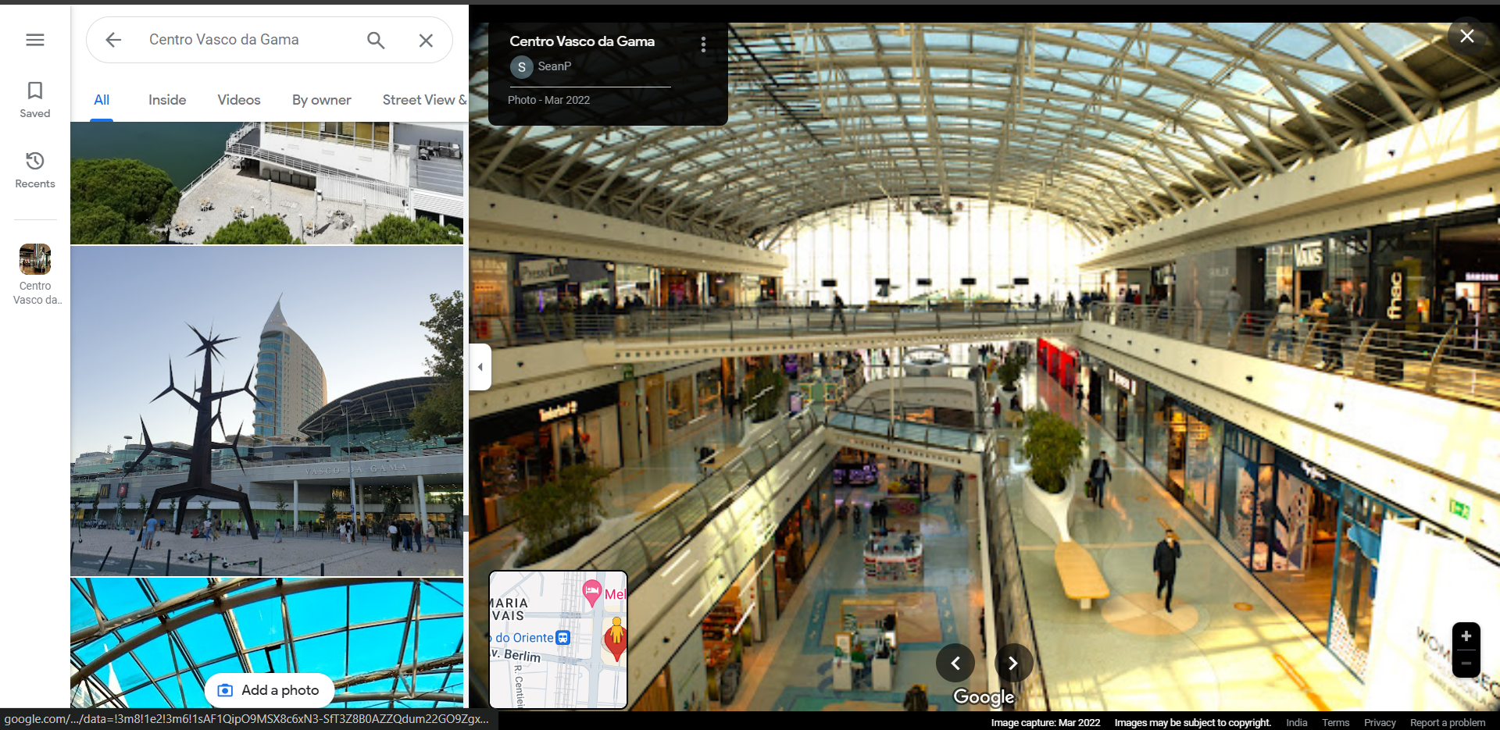

1. I search the selected part in a google lanse and find that this is a

Tutankhamun Pavilhao de Portugal poster

<https://tutankamon.pt>

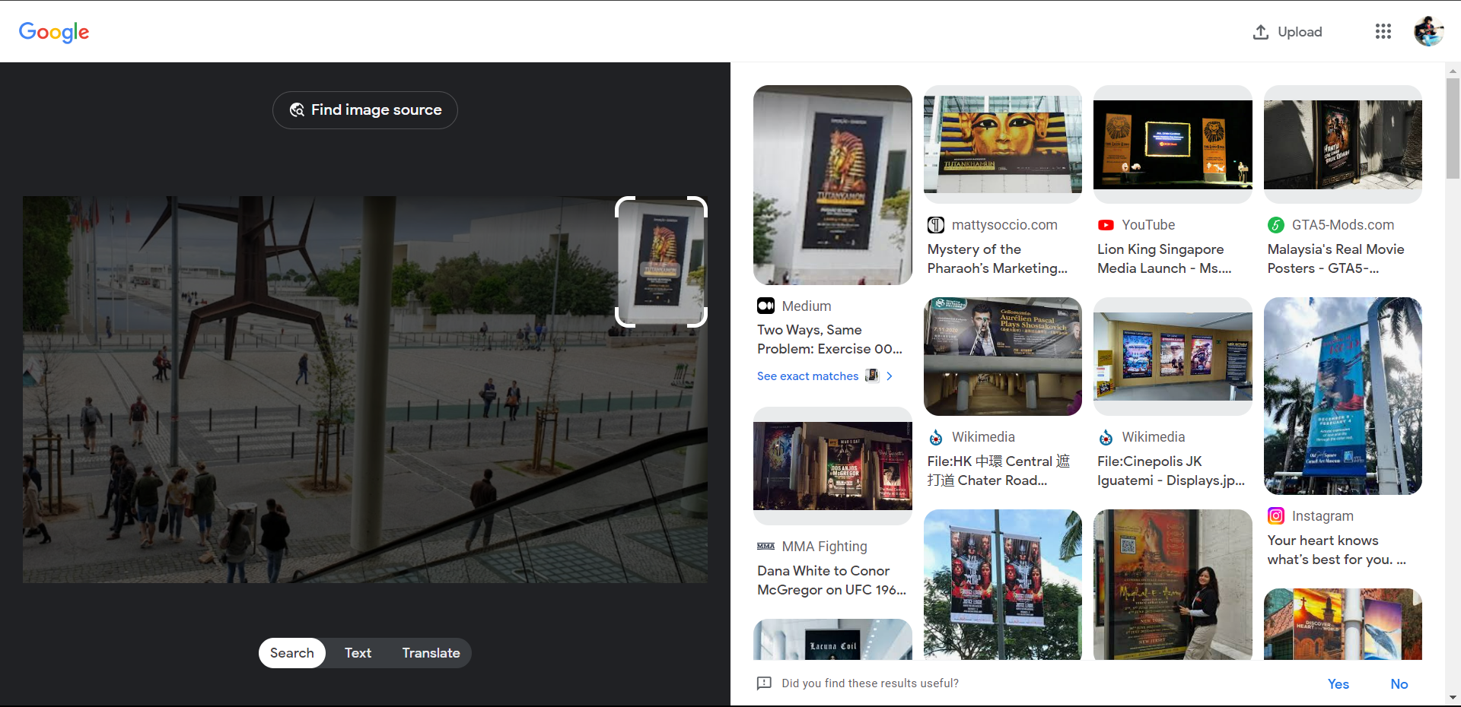



1. This image shows the date of 19 ABRIL 2019

I see the past photo and videos on a google map

I found one video from august 2018

There is no poster there

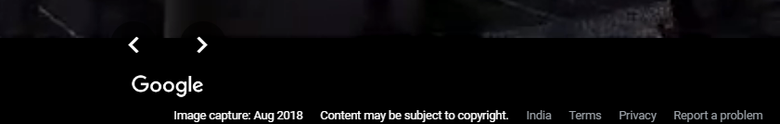



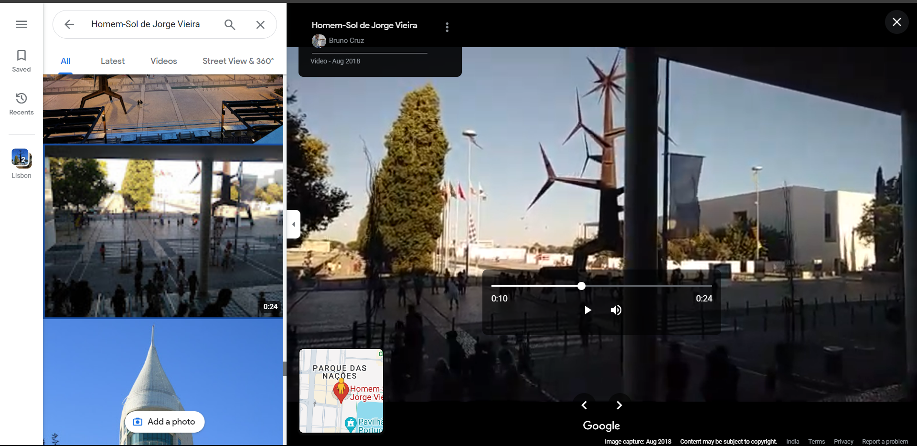



I found another image from Sep 2019 where the poster is appeard in a image

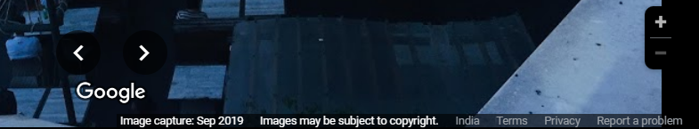



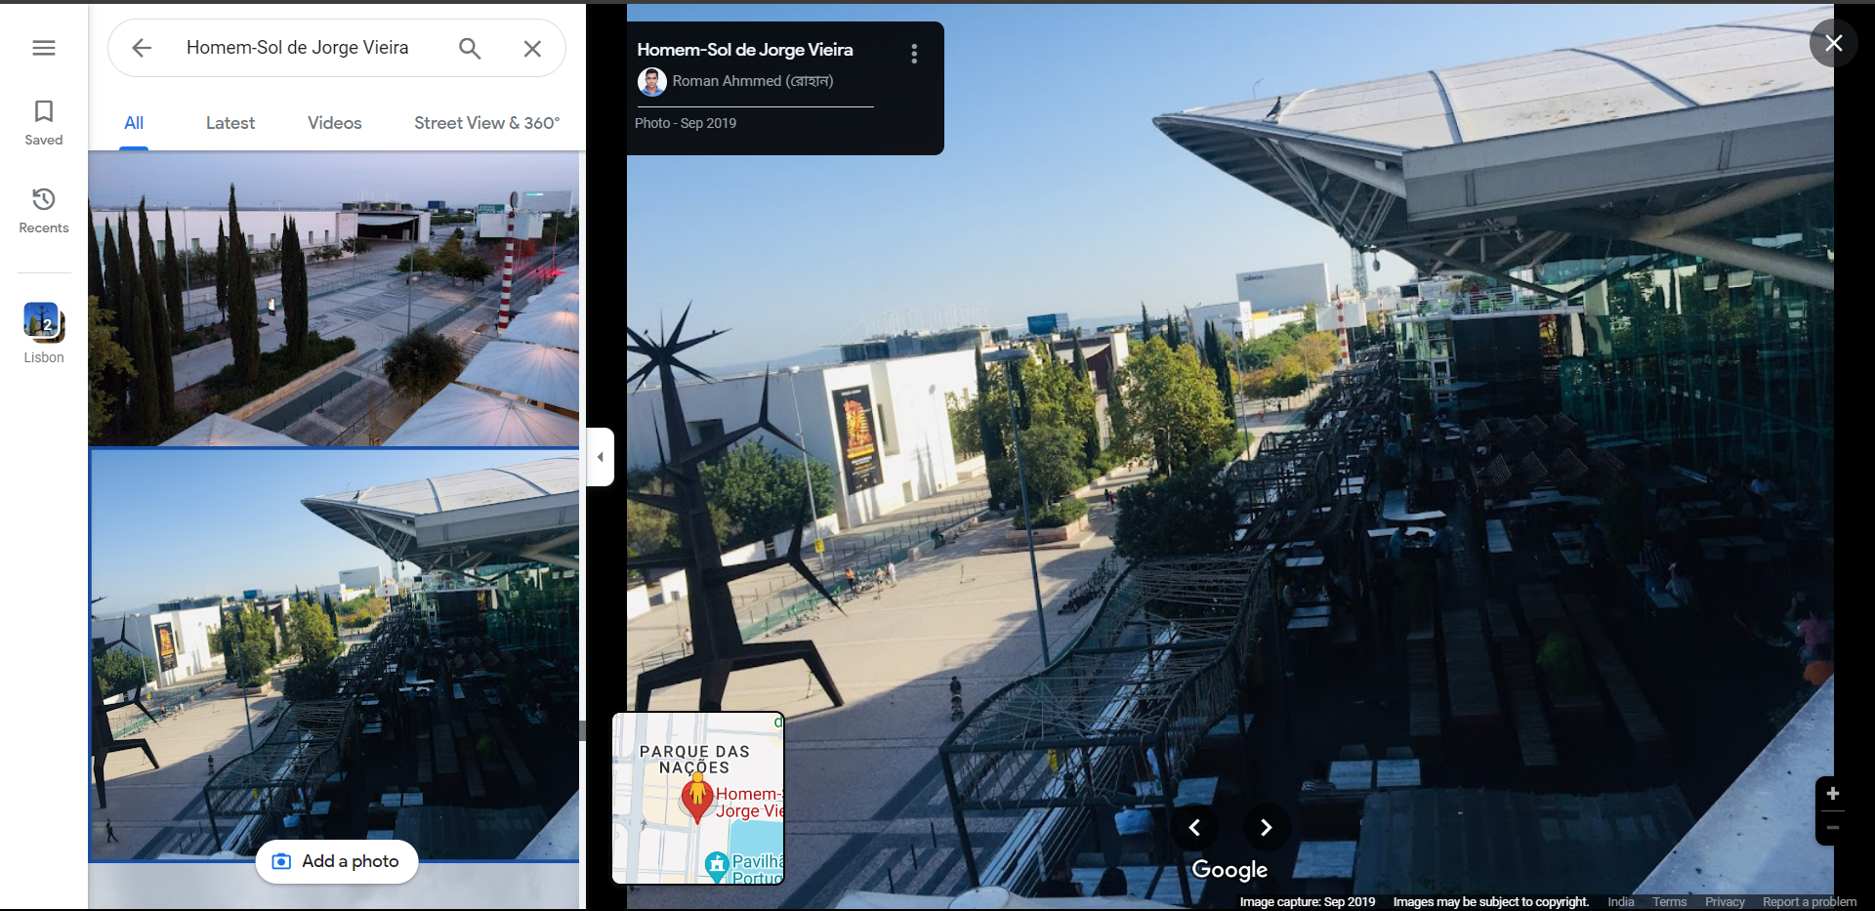



So we can say that image is taken in 2019